**Advance java script**

**Dom :It is a structure of html elements which are converted into objects(nodes)and arranged all the objects in tree data structure.**

browser engine will read the html code in bytes.

bytes---characters --- tokens---- objects(nodes)

html elements ---- objects(nodes)

|

|

(It will link all the nodes in the sequence and all the nodes will be placed in the tree data structure and the tree data structure we are going to call as a dom.

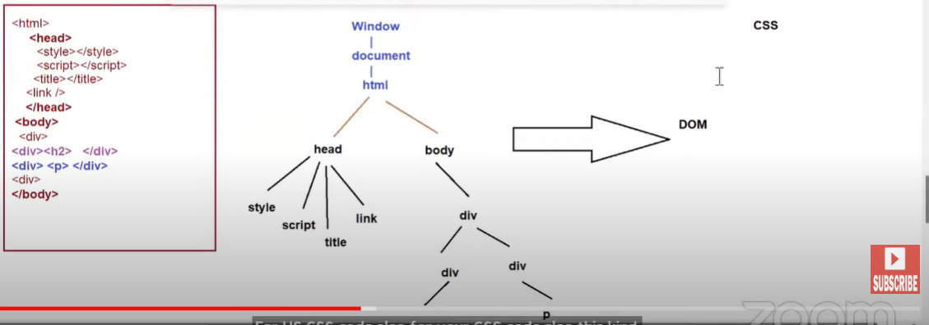

for the web page == (Dom + CSSOM = rendering tree = paint the screen)

**Why dom is created ?**

**Using the java script we can manipulate the html document so that we can create dynamic user interface**

**Using the java script we can change the content, delete the element, add the element in the user interface. This all instruction are called as dom manipulation.**

**Dom manipulation : changes such as add , delete , update in an user interface is called as dpom manipulation.**

**How to access any dom node (html element)**

**How to add new html element?**

**How to remove existing html element?**

**How to change content or attributes of html element?**

**Answer: Browser will provide us pre-defined objects and functions. it is caaled as Dom API’S**

**How to access html elementi n the java script ?**

**Ans : we have four ways**

**Id value**

**Class value**

**Tag name**

**Name attribute**

**How to integrate html and java script?**

Ans : we have to add script tag which can be added in head or body section.